COMPUTER STUDIES PAPER 1
FORM 4 END TERM 1 2025
MARKING SCHEME
- State two health issues that could arise from the use of unsuitable computer desk (2 marks)
- It could lead to back problems if the desk is unrealistically high
- Wrist problems could arise
- Eye strains as a result of poor monitor positioning
- Give two reasons why portable computers like laptops and tablets are becoming popular in the modern society (2 marks)
- Portable therefore can be carried from one place to another with ease
- Have rechargeable battery
- Advance technology where peripheral devices are integrated as one unit
- Warranty is one of factors to put into consideration when acquiring computer hardware. State two contents of a warranty (4 marks)
- Period/Duration/ Scope of cover –Should specify the duration of time covered
- Liability agreement-It should indicate cost sharing between the seller and the buyer in case of any loss or malfunction
- Callout response
- Service agreement- The warranty should indicate the type of service to be provided
- List four devices that use scanning technology to capture data directly from the source (2 marks)

- OBR
- MICR
- OCR
- OMR
- Image scanner
- Face recognition
- Fingerprint

- State two ways in which hardware failure is a threat to data security (2 marks)
- Data loss due to total system failure eg. HD crash
- The experts called upon to repair can access critical / valuable information
- Data recovery software can be used to make unauthorized back ups
- Given the binary number 1101110100111100 , determine the number of :
- Nibbles - 4 (1 mark)
- Bytes - 2 (1mark)
- (a) State the role of the following communication devices
- Repeater (1 mark)
- A device that receives weak signals and amplifies it for propagation along the next leg of the medium
- Router (1 mark)
- A device used in wide area network to interconnect different networks

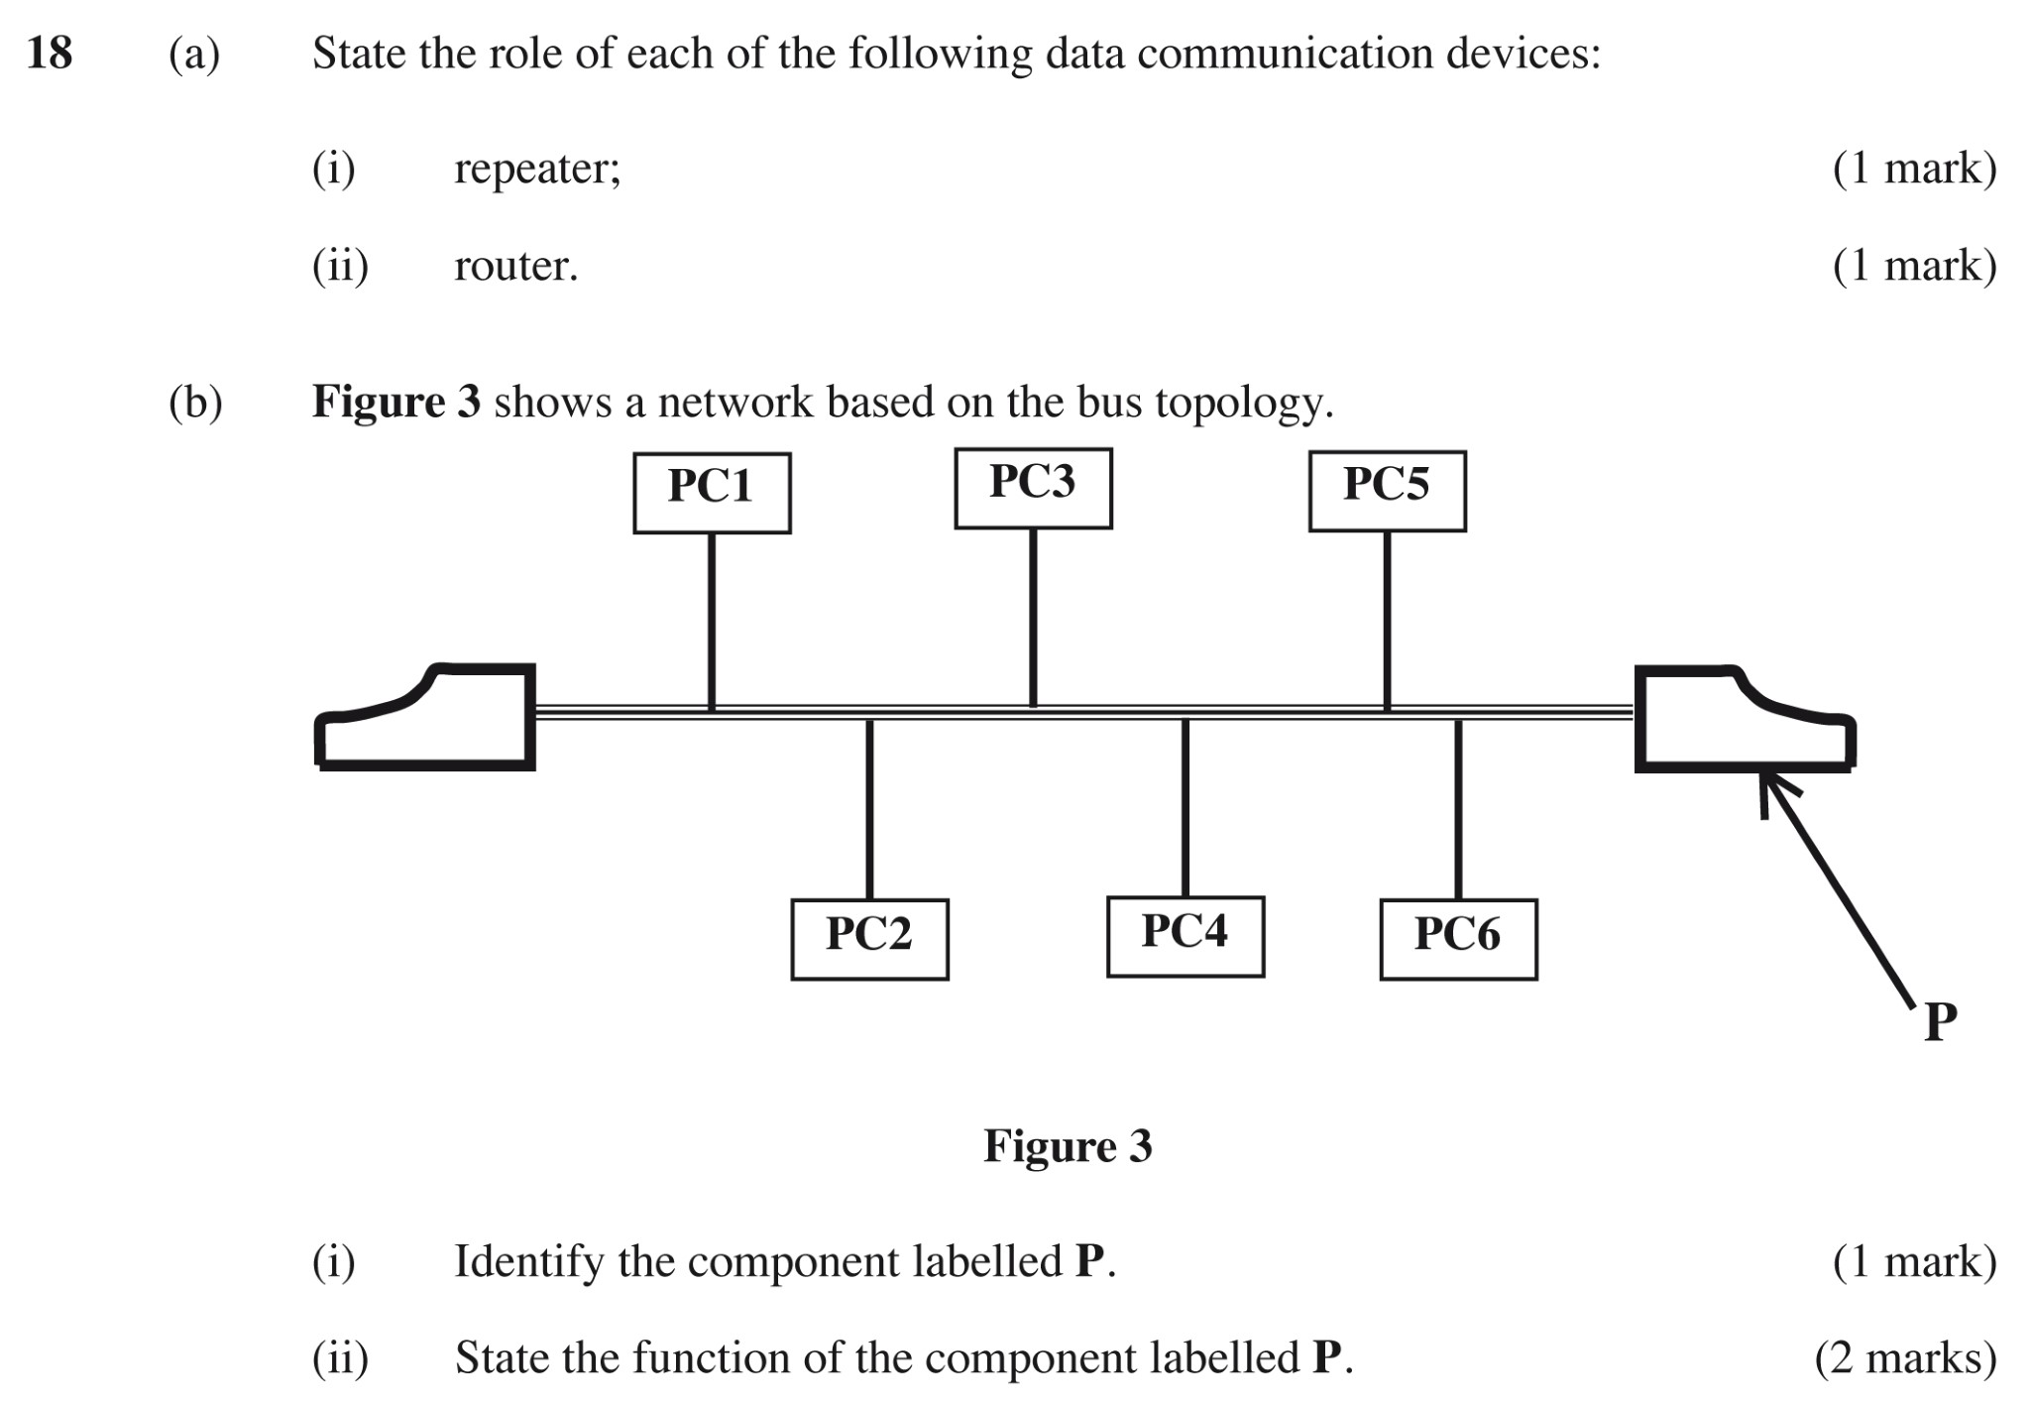
(b) The figure below shows a type of network topology. Use it to answer the questions that follow;

- Identify the topology represented above (1 mark)
- Bus topology
- Name the component labelled P (1 mark)
- Terminator
- State the function of the component labelled P (1 mark)
- Used to prevent signals from bouncing back/ absorb signals
- Five students Walter, Faith, Mercy, Diana and Joachim scored the following marks in Mathematics 35, 76, 98, 44, and 54. They were recorded in cell C3 to C7. The teacher wanted to rank them in descending order so as to award them
- Write down an appropriate formula that the teacher used
- =Rank(C3, $C$3:$C$7,0) The range must be absolute to score full mark
Award 1 mark for the correct function
Award 1mark for correct bracket to bracket

- Their grades were assigned as follows
80-100 ……………. A
60-79 ………………B
40-59 ………………C
Less Than 40 ……..Fail
Write the formula used to assign the grades above
- =IF(C3>=80,”A”, IF(C3>=60,”B”, IF(C3>=40, “C”,”FAIL’)))
Award ½ for correct 4 condition max 2
- Differentiate between hardware and software portability
- Hardware portability refers to the ability of the computer to be carried from one place to another with ease.
- Software portability refers to the ability to install a program in two or more computers

- Differentiate between formatting and editing as used in word processor (2marks)
- Formatting refers to applying various styles to enhance the documents appearance
- Editing refers to making necessary changes to a document
- Explain the meaning of the following terms as used with DTP (4marks)
- Crop- trim graphics
- Embedded objects – separate file not created in the program in use but in another and placed in the program in use.
- Master page - A page used to design general layout that needs to be applied in other pages.

- Explain the following as used in data security (3marks)
- Fraud – Stealing by false pretense
- Eaves dropping – Tapping into Communication Channel to gain access to sensitive information
- Information Security – Ensuring of safety of data and information against threats
- Distinguish between relative cell referencing and absolute cell referencing as used in computing giving an example in each case (4 marks)

- Relative referencing- When a cell is copied, it adjusts to its new location eg A1
- Absolute referencing –A cell is referred to (referenced) regardless of its location eg =$A$1

- Explain the following monitor terminologies as used in computing. (3 marks)
- Resolution- number of pixels per inch on the screen
- Pixels- Tiny dots that form the images displayed on the screen

- State four stages in data processing (2marks)
- Data collection
- Data input
- Processing
- Output

- Dry running
- Use of translators
- Debugging utilities (award 3 marks well explained)

start
Name, years
Basic salary,sales
Experience
>10 years
Sales >
200,000
Sales between 100,000 & 200,000
Bonus = Sales x 0.05
Gross = Basic + Bonus
Benefit = Basic * 0.1
Bonus = sales * 0.15
Bonus = sales * 0.1
Print Name,
Basic salary, Bonus Gross salary
STOP
1mk
1mk
1mk
Yes
1mk
No
Yes
1mk
1mk
No
1mk
1mk
No
1mk
1mk
1mk
1mk

- a) ) State two ways of representing a signed binary number. (2 marks)
- Prefixing an extra sign bit to a binary number
- Using 1’s complement
- Using 2,s complement
b) 7.03125₁₀ to binary
2 | 7 | Rem
2 | 3 | 1  1mk
2 | 1 | 1
 | 1 | 1
7₁₀ = 111₂
0.03125 x 2 = 0.0625 0
0.0625 x 2 = 0.125 0 mark
0.125x 2=0.25 0
0.25x2=0.5 0
0.5x2=1.0 1

= 0.00001₂
Combine the two
.: = 111.00001₂

- Perform the following binary operations; (2 marks)
- X₂+1101₂=70₁₀

70₁₀ to binary 1000110₂
1000110₂-1101₂=111001₂
- Solve the following using twos complement 12₁₀-28₁₀ (4 mks)
28 to binary 11100₂
12 to binary 1100₂
12+(-28)
Balance the bits
28₁₀=11100₂
5 bits each
12₁₀=01100₂

The 1’s compliment of 28- 00011₂
The 2’s compliment of 28 + 1
00100
01100₂+00100₂=10000
- Invert the bits of 10000₂:
- 10000 → 01111
- Add 1:
- 01111 + 1 = 10000₂ Accept 8 bits working

e ) i) Letter N is represented by 1001110 using a certain coding scheme. Identify the type of coding scheme used (1 mark)
- American Standard Code for Information Interchange (ASCII) coding scheme. ASCII uses 7-bit binary codes to represent characters, and 1001110 is the 7-bit binary code for the letter N.
ii) Using the same coding scheme named in C (i) above, show how letter K can be represented (2 marks)
1001110₂​= 78₁₀ =N
K =75₁₀= 1001011₂

- i) Online processing – data is processed immediately as internet banking, online payment system using credit card (2mks)
ii) Batch processing – data is accumulated as a group as grading system in a school (2mks)
b) i) Logical file and physical file
- Viewed in terms of what item it contains & details of what processing operations may be performed on the data items.
Physical files are one that is viewed in terms of how data is stored on a storage media (2mks)
ii) Master file and back - up file
Master file is the main file that contains relatively permanent records. Back up files used to hold copies of data or information from fixed storage (hard disk) (2mks)
c) An organization is facing threats to data integrity. Explain three ways on of how the threats can be minimized (3marks)

- Back up data
- Control access of data by enforcing security measures
- Design user interface that minimize unauthorized access.
- Use error detection and correction softwares
- Use device that directly capture data from source document i.e. digital camera, optical CR

d) Write the following acronyms in full
- EBCDIC
Extended Binary Coded Decimal Interchange Code
- COBOL
Common Business Oriented Language
- ASCII
American Standard Coded for Information Interchange
- BCD
Binary Coded Decimal
19. The table below shows an extract of a spreadsheet document.Use it to answer the following questions.
 | A | B | C | D | E | F
1 | ITEM NAME | NUMBER OF ITEMS | UNIT COST | TOTAL BUYING PRICE | TOTAL SELLING PRICE | PROFIT
2 | PENS | 50 | 25 |  |  | 100
3 | BOOKS | 15 | 70 |  |  | 750
4 | CUPS | 30 | 120 |  |  | 500
5 | RUBBER | 75 | 15 |  |  | 250
- What data type will be used to represent content of cell A2,C2 and E2? (3 marks)
A2- Label
C2- Values
E2- Formula
- State how cell F5 can be represented using R1C1 style? (1 mark)
In R1C1 notation, both rows and columns are referenced by numbers.
- F5 is the intersection of column F and row 5. In R1C1 style, this would be R5C6, where R represents the row number and C represents the column number.
R5C6
- Which formula can be used to compute;
i)Buying price (1 mark)
=B2*C2
Or
=Product(B2:C2)

ii)Profit (1 mark)
=E2-D2
- Write a function that will enable you get the product with the max profit (2 marks)
=Max(F2:F5)

- Explain the following editing tools in (4 marks)
i) Label –They identify data along each axis
ii) Legend- The key that identifies data series

iii) Chart title- Identify chart purpose and explains the data displayed in the chart

iv) Data markers- They graphically represent each data point in each data series

- Explain the concept of subtotals (3 marks)
This is a function used to summarise a worksheet list to display grouped totals.The list is grouped using a preffered field.To generate subtotals you first sort the list into specific rows so that they are gouped together.
20 .a) Which data communication are represented below ( 3 marks)
- A police officer talking over a walkie talkie
Half-duplex

- A pastor speaking to Christians using public address

simplex

- A student speaking to their parent over the mobile phone

Full duplex
b) Explain the following application areas of ICT. (5 marks)
i)Retail system
Electronic point of sale terminal
Stock control
ii)Education system
E-learning
Computer aided learning
Computer based simulation
iii)Transport System
E-ticketing
Control of traffic in air, shipping and automobile
iv)Scientific Research
weather forecasting
medical research
military and space research
v)Entertainment System
recording, editing and adding effects on music production
Gaming

- A teacher had a document of 20GB in a hard disk. He wanted to transfer the document into a CD of 700MB. Determine the number of CD’s he requires (2 marks)

1GB=1024 MB
(20GB*1024)/700
=29.25714
=Approximately 30 CD’s
- Students of Amani high school intend to elect their school captain by secret ballot. State three ways high computers can improve the election process (3marks)
- Preparing and printing voting material
- Biometric identification of voters
- Registration of voters
- Election analysis
- The following URL was typed by Amina:
http://www.cie.org.uk/computer studies
The URL composed of three parts; state the part of the URL that represents:
- File name Computer Studies
- Protocol http
- Web server name cie

